### AMP 154 PWR Pressurizer (VERSION 2020)

### Programme Description

The approach used by some operators (e.g. WWER, CANDU) to AMPs development is focused on components (such as RCP, RPV, SG, Pressurizer, etc.) and not on individual degradation mechanisms. These “umbrella type” programmes are based on understanding of all degradation mechanisms relating to the specific component and describing all activities necessary to manage ageing. The main advantage of such an approach is knowledge of the overall state of the components.

This ageing management programme is a component-specific AMP for the pressurizer, that covers multiple degradation mechanisms the pressurizer may be subjected to and the activities necessary to manage the ageing mechanisms. As such, this AMP refers to other degradation-specific and/or monitoring type of AMPs that deal with particular degradation mechanisms and ageing effects.

The pressure boundary of the pressurizer is safety class 1 component therefore it is included in the scope for LTO in accordance with the IAEA Safety Report Series No. 57 [1].

### Evaluation and Technical Basis

1. ***Scope of the ageing management programme based on understanding ageing:***

The programme controls ageing of the pressurizers. The following ageing degradation mechanisms are considered in this AMP (see Table 1 and Figure 1):

* Fatigue;
* General corrosion;
* Boric acid corrosion;
* Stress corrosion cracking;
* Wear;
* Loss of preload;
* Thermal ageing.

Examples of critical locations for fatigue of pressurizer are nozzles and the flanged joints.

Examples of critical locations for general corrosion of pressurizer are the external surfaces and the support structures.

Bolting and support structures used on Pressurizer could be in carbon steel thus boric acid corrosion is a potential degradation mechanism.

Stress corrosion cracking can happen in stagnant localized corrosion susceptible location, e.g. nozzles, collectors, surge-line of Pressurizer.

Degradation due to wear or stress relaxation could be applicable to fitted connections such as bolts, internal parts of Pressurizer.

Degradation due to loss of preload could be applicable to fitted connections such as bolts and keys.

Examples of critical locations with potential degradation mechanisms are summarized in Table 1.

|  |  |  |  |  |  |  |  |  |
| --- | --- | --- | --- | --- | --- | --- | --- | --- |
| **Loc. ID** | ***Degradation mechanism*** | ***Fatigue*** | ***General corrosion*** | ***Boric acid corrosion*** | ***Local corrosion (incl. SCC)*** | ***Wear*** | ***Thermal embr.*** | ***Loss of preload*** |
| **Critical location** |
| **1** | **Man-hole with sealing and bolted connections** |  | **+** | **+** | **+** | **+** | **+** | **+** |
| **2** | **Water injection nozzle with thermal shielding tube** |  |  |  | **+** |  | **+** |  |
| **3** | **Water injection collector and its location** | **+** |  |  | **+** | **+** |  | **+** |
| **4** | **Thermal shield and the connecting supports** |  |  |  | **+** |  |  |  |
| **5** | **Pressurizer casing (incl. welds, cladding, particularly to water-steam boundary)** | **+** |  |  | **+** |  | **+** |  |
| **6** | **External surface of the vessel with the connected support structures and earthquake protection components.** |  | **+** | **+** | **+** |  |  |  |
| **7** | **Bottom nozzle and the surge line** | **+  (inner radius cladding)** |  |  | **+** | **+  (under dissimilar weld)** | **+** |  |
| **8** | **Heating battery support shield and the fastening elements** |  |  |  |  | **+** |  |  |
| **9** | **Nozzles of the electrical heating batteries, the battery linings, cladding of the nozzle location** | **+** |  | **+** | **+** | **+** | **+** |  |
| **10** | **Measurement nozzles** | **+** |  | **+** | **+** |  | **+** |  |

**Table 1.** Example of pressurizer critical locations and degradation mechanisms

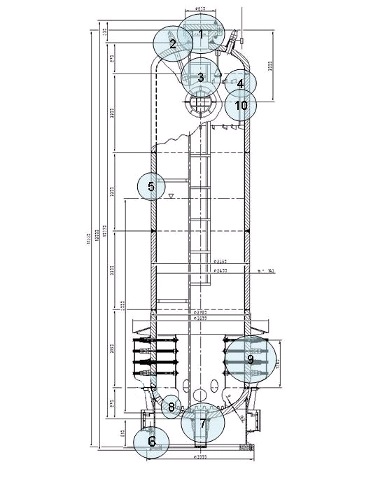

**Figure 1.** Pressurizer with the critical locations

1. ***Preventive actions to minimize and control ageing degradation:***

The preventive actions are carried out during normal operation via monitoring and management of water chemistry conditions. These actions could eliminate potential adverse effects of water chemistry on the ageing mechanisms. The programme description, evaluation and technical basis for monitoring and maintaining of reactor coolant chemistry are addressed in AMP 103.

Other preventive action is regular maintenance according to approved schedule (such as general repair, inspection of sealing screw tightness and inspection programme of the hermetic area).

Preventive actions for low cycle fatigue include reduction of transients and keeping limits and conditions.

1. ***Detection of ageing effects:***

The pressurizer is inspected and tested according to the requirements of AMP 102. Non-destructive methods such as visual examination, capillary test to detect surface cracks, dimensional control and ultrasonic examination may be used. It is expected that visual, surface or volumetric inspection performed within AMP 102 will detect cracking due to SCC, fatigue, growth of manufacturing defects, or common wear by inspecting for loose connections or missing parts.

The impact of boric acid leakage on bolting materials is addressed by AMP 110.

The cumulative effect of fatigue is addressed by AMP 101.

1. ***Monitoring and trending of ageing effects:***

Timely and reliable detection of ageing degradation is provided by implementation of inspection and testing schedules in accordance with the referred AMPs in attribute 3, reliable examination methods, and qualified inspection. Monitoring and trending is performed as per the AMPs listed in attribute 3.

1. ***Mitigating ageing effects:***

Recommendations for mitigation of ageing effects are based on referred AMPs in attribute 3, and on results from performed analyses of possible degradation developments.

1. ***Acceptance criteria:***

Acceptance criteria are part of referred AMPs in attribute 3, and maintenance procedures. Any indication or relevant conditions of degradation may be evaluated for acceptance in accordance with the governing requirements or guidance documents as for example [2-5].

1. ***Corrective actions:***

In order to satisfy the safety requirements, further evaluation to demonstrate fitness-for-service of the component until the end of the next periodic inspection interval may be required. Examination results and flaws that exceed the acceptance criteria given in the governing requirements or guidance documents may require activities such as repair or replacement.

For each acceptance criterion which is not satisfied, the procedure for resolution is defined or elaborated and consequently implemented, according to the referred AMPs in attribute 3. At the end of the process the criterion is fulfilled and the requested state of the component is restored. Repair and replacement according to requirement of technical documentation of the components and according to guiding documents of the plant are part of possible corrective actions.

When suitable in some cases, changes of operational regimes could be applied.

1. ***Operating experience feedback and feedback of research and development results:***

This AMP addresses the industry-wide generic experience. Relevant plant-specific operating experience is considered in the development of the plant AMP to ensure the AMP is adequate for the plant. The plant implements a feedback process to periodically evaluate plant and industry-wide operating experience and research and development (R&D) results, and, as necessary, either modifies the plant AMP or takes additional actions (e.g. develop a new plant-specific AMP) to ensure the continued effectiveness of the ageing management.

Appropriate sources of external operating experience are WANO Operating Experience Programme, IAEA IGALL Programme, etc.

The operational history of the component is analyzed once per inspection or test cycle according to the member states practice. There is a system in place to incorporate feedback from internal and external operating experiences.

The values of ageing management parameters and corresponding analysis (in case that they were performed) are evaluated according to the referred AMPs in attribute 3.

Observations of degradation of WWER-440 pressurizers include wear of closure bolting components. It has been managed primarily through improved control of pre-load or repair of sealing surfaces. Preventive action e.g. replacement of bolts and Ni sealing rings of manway for another type (graphite, HAEA HA-5549, HA-5554, HA-5560, HA-5605) precluded the effect of ageing. Existing condition monitoring programmes of critical locations (ISI, maintenance program) inspect for the extent of ageing effects of wear.

Effective experience exchange is important element for implementing continuous improvement in this programme and in defining adequate corrective actions.

This programme includes provisions for continuing review of plant-specific and industry-wide operating experience, and research and development results, such that impact on the programme is evaluated and any necessary actions or modifications to the programme are implemented.

At the time when this AMP was produced, no relevant R&D was identified.

1. ***Quality management:***

The AMP is carried out in agreement with site QA procedures, review and approval processes, and administrative controls, which are implemented in accordance with the different national regulatory requirements for example [6-7], or the different national standards, and regulatory requirements [5].

Pressurizer Pre-Service Inspection (PSI) and In-Service Inspection are performed by the same instruments, devices, tools, methods and experts as possible as to reduce probability of extra error occurrences.

The personal performing these inspections is certified by international or national legal organization. Certification process contains necessary education, work experience and other abilities.

### References

1. INTERNATIONAL ATOMIC ENERGY AGENCY, Safe long term operation of nuclear power plants, Safety Report Series No. 57, IAEA, Vienna, 2008.
2. Unified Procedure for Lifetime Assessment of Components and Piping in WWER NPPs during Operation, European Commission, COVERS – WP-D4.10, project VERLIFE, 2008.
3. NUCLEAR REGULATORY AUTHORITY OF THE SLOVAK REPUBLIC, Aging management of NPP - requirements, National safety guide BNS I.9.2/2014, UJD-SR, 2014.
4. STATE OFFICE FOR NUCLEAR SAFETY OF CZECH REPUBLIC, Aging management of NPP, National safety guide BN-JB-2.1, SUJB, 2015.
5. Hungarian Atomic Energy Agency: Guideline 4.12. Ageing management during the operation of NPPs, March 2016.
6. STATE OFFICE FOR NUCLEAR SAFETY OF CZECH REPUBLIC, [Decree No.132/2008](http://www.sujb.cz/fileadmin/sujb/docs/legislativa/V1322008.doc) on Quality Assurance System in carrying out activities connected with utilization of nuclear energy and radiation protection, SUJB, 2008.
7. NUCLEAR REGULATORY AUTHORITY OF THE SLOVAK REPUBLIC, Regulation No. 431/2011 on a quality management system, 2011, UJD-SR.